Map Coloring using CSP
AIM:
To write a Python program to solve the Map Coloring Problem using Constraint Satisfaction Problems (CSP).

ALGORITHMS:
- Start.
- Define the regions and their neighboring regions.
- Define the available colors.
- Select an uncolored region.
- Assign a color to the selected region.
- Check whether any neighboring region has the same color.
- If the assignment is valid, select the next uncolored region.
- If the assignment is invalid, try another color.
- If no color is valid, backtrack to the previous region and change its color.
- Repeat until all regions are colored or no solution exists.
- Display the solution.
- Stop.
CODE:
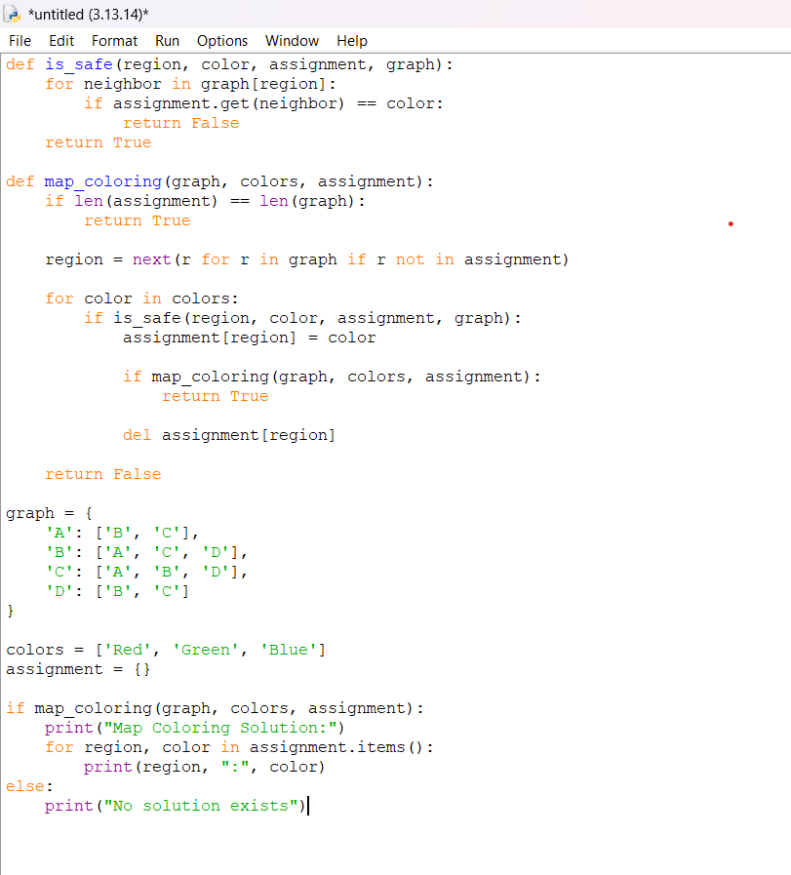

OUTPUT:
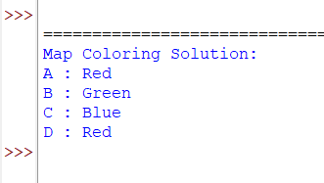

RESULT:
Map Coloring using CSP: The map is colored so that no two adjacent regions have the same color.

